Media Release
15 December 2014

Property rents plateau in November

The median national rent was unchanged at $400 per week in November, but is up more than 5 per cent since November 2013, according to the Trade Me Property Rental Index out today.

Head of Trade Me Property Nigel Jeffries said the median weekly rent had been “stuck in the mud” for four consecutive months. “There’s less price pressure on tenants and a healthy supply of properties for rent in many areas. Although the weekly rent is holding steady at $400 per week, the year-on-year increases are trending down.”

He said the rental sector was quietening, at the same time as asking prices for residential property sales were emerging from a winter slump.

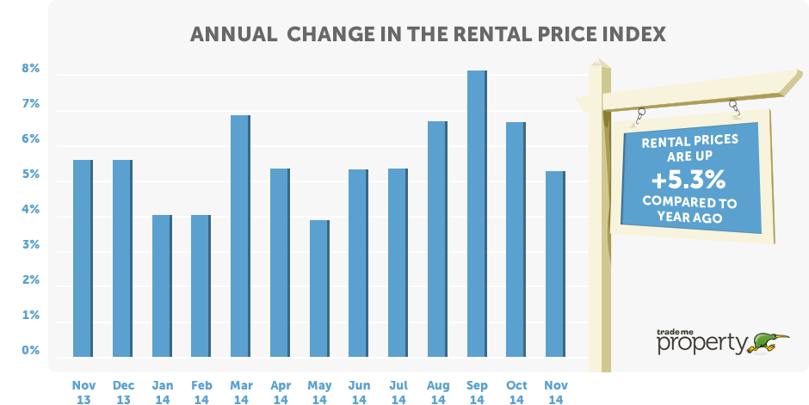

Rents growth slows compared to prior years

Looking at the long-term trend, growth in median weekly rents is dominated by the period between 2011 and 2014, despite the plateau in the past six months. Since 2009, the median weekly rent has risen by more than 21 per cent. This compares with a 28 per cent increase in average asking prices for residential properties over the same period.

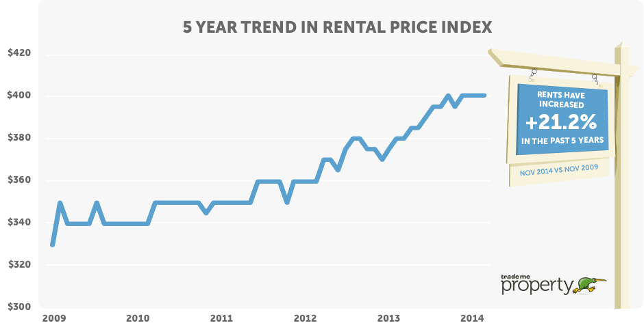

Ups and downs across the regions

Three regions recorded year-on-year falls in weekly rent: the largest was in Manawatu/Wanganui where it fell almost 10 per cent to $230 per week, well below the region’s peak of $260 per week in October 2013.

The West Coast continues to be weak, down 4 per cent on a year ago to $240 per week. Otago landlords have enjoyed strong median rent rises of around 6 per cent most of 2014, but median rents slipped 1.6 per cent this month.

Twelve regions saw median rent increases, led by Taranaki which is up 16 per cent to $350 per week – tenants are paying fifty dollars more than they were a year ago. The top of the South Island is also showing increased activity with both Nelson and Marlborough recording new highs of $360 per week and $318 per week respectively.

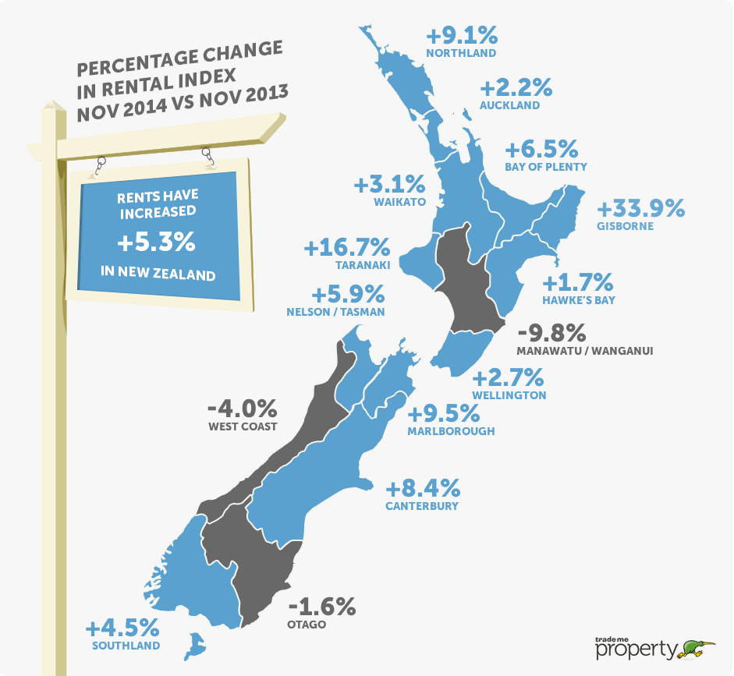

Pressure remains in Christchurch but Auckland easing

Mr Jeffries said the tight rental market in Christchurch was still in play, and although the median weekly rent of $450 had not budged since October it was up almost 6 per cent on a year ago. Beyond the headline figure for all properties the recent pressure around large and medium-sized houses has decreased slightly with a year-on-year fall of 0.7 per cent to $695 per week.

Auckland was also unchanged on $460 per week – but still at a record-equalling high. Mr Jeffries said there were hints that the rental market was easing in the City of Sails, with a 2.2 per cent increase compared to November last year.

In Wellington there was a 2.7 per cent rise in weekly rents, underpinned by a 10 per cent lift for medium-sized houses to $440 per week (still $40 per week lower than the all-time high back in January 2014).

Table 1: Median weekly rent by property size & region

 | New Zealand | Auckland | Wellington | Christchurch
All property types | $400  + 5.3% | $460  + 2.2% | $380  + 2.7% | $450  + 5.9%
Large houses  5+ bedrooms | $650  + 8.3% | $720  + 4.3% | $680  - 2.9% | $695  - 0.7%
Medium houses  3-4 bedrooms | $450  + 9.8% | $520  + 4.0% | $440  + 10.0% | $500  + 4.2%
Small houses  1-2 bedrooms | $320  + 8.5% | $385  + 4.1% | $325  + 5.7% | $360  No change

Townhouses see strong lift

Townhouses reached a new high with a national median rent of $450 per week, up 7 per cent as compared to last year.

The unit market remains strong with national weekly rents at $310 per week, down just $10 from the record high in October. In Christchurch, the pressure has pushed this segment of the market to a new high of $340, up 6 per cent on a year ago.

Table 2: Median weekly rent by property type & region

 | New Zealand | Auckland | Wellington | Christchurch
All property types | $400  + 5.3% | $460  + 2.2% | $380  + 2.7% | $450  + 5.9%
Apartments | $390  + 2.6% | $410  + 2.5% | $400  + 1.3% | $375  + 2.0%
Townhouses | $450  + 7.1% | $500  + 2.0% | $420  + 5.0% | $450  + 4.7%
Units | $310  + 3.3% | $370  + 2.8% | $280  No Change | $340  + 6.3%

-ends-

MORE INFORMATION

About the Trade Me Property Rental Price Index:
- The Index provides a timely and comprehensive monthly insight into the New Zealand rental market. It covers trends in rents by type and size of property across New Zealand.
- Produced from data on properties rented in the month by both property managers and private landlords.
- It is calculated based on median rent.
- URL: trademe.co.nz/property/price-index/for-rent

